**ANALYSIS OF NITRIC OXIDE SENSOR READINGS AT DIFFERENT CONCENTATIONS**

**Nitric oxide sensor readings without supplying nitric oxide gas**

o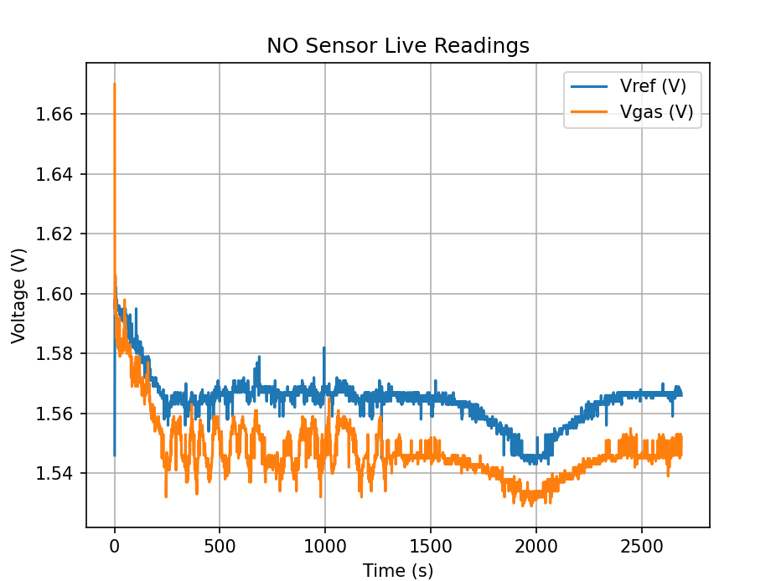

Figure 1: Nitric oxide voltage values vs time *plot without butter worth filter* over 2500 seconds

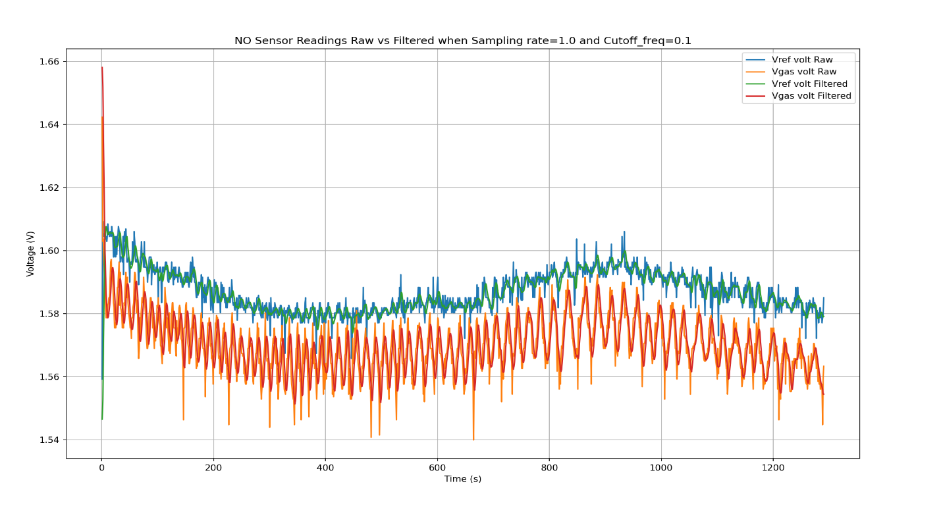

Figure 2: Nitric oxide voltage values vs time plot with butter worth filter (Fs=1 and Fc=0.1) over ~1200 seconds

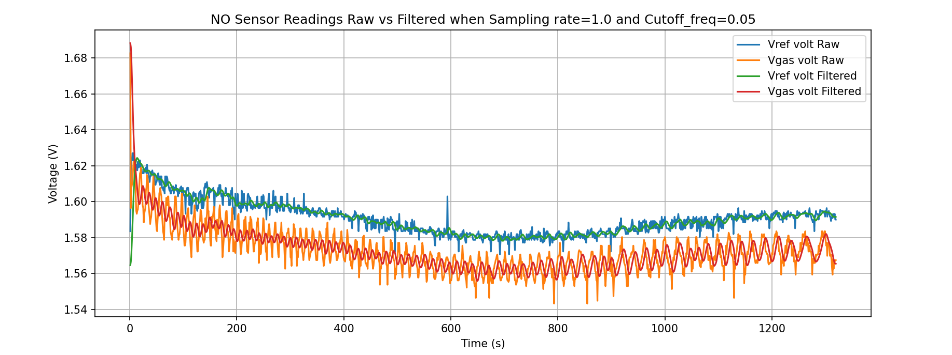

Figure 3: Nitric oxide voltage values vs time plot with butter worth filter (Fs=1 and Fc=0.05) over ~1200 seconds

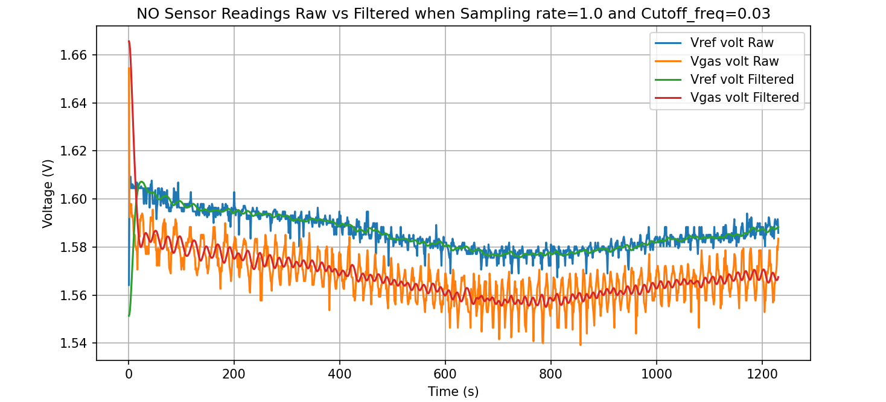

Figure 4: Nitric oxide voltage values vs time plot with butter worth filter (Fs=1 and Fc=0.03) over ~1200 seconds